ACIE Annual Scottish Conference 2019
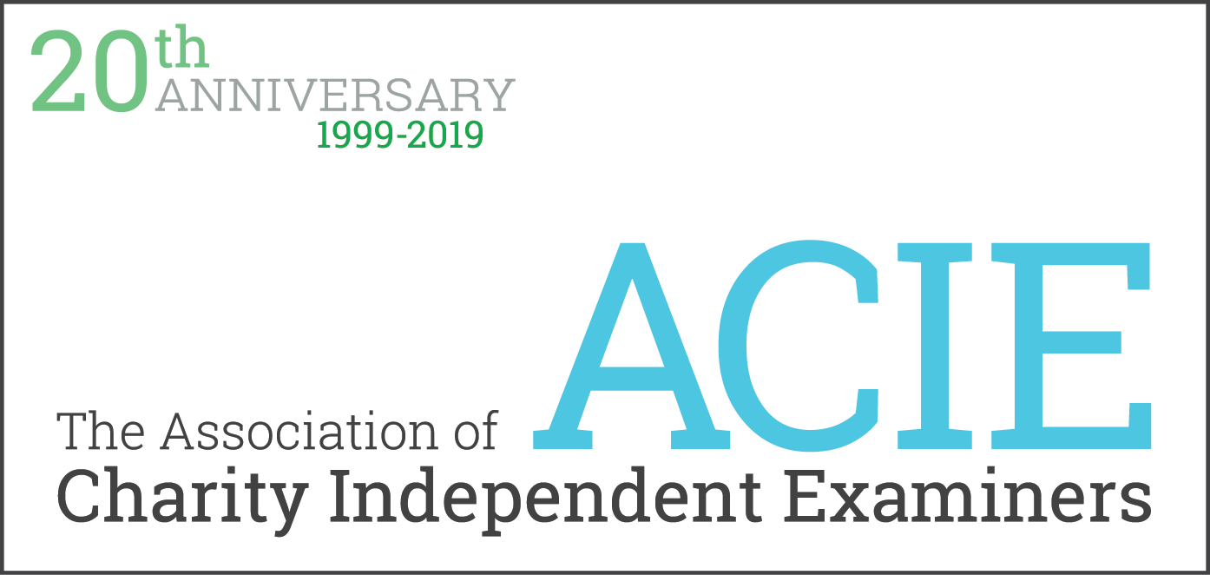

22nd August 2019
Open to Members and non-members
(Programme may be subject to changes)

Mill Street, Perth, PH1 5HZ
Registration open from 09:30 – The conference runs from 10:00 to 16:30

Conference Programme:

09:30 - 10:00 | Registration - Tea & Coffee (Foyer)
10:00 - 10:10 | Welcome and opening remarks from Chair
10:10 - 10:40 | Update from the Regulator: Martin Tyson, OSCR

10:45 - 11:45 | Workshops Session 1
Norie-Miller | Charities and the Management of Risk, Tom Mitchell, CGPM consulting llp
Tilt | Charities, Tax and Trading, Jenny Simpson (Wylie & Bisset)
Earn | Good Governance Guide for Charities, Shirley Otto (MDNinS)

11:45 - 12:00 | Tea & Coffee

12:05 - 13:05 | Workshop Session 2
Norie-Miller | Launch of new Independent Examination Workbook, Michael Brougham
Tilt | Gift Aid, Susan A. Robinson

13:05 - 13:55 | Lunch (Foyer)

14:00 - 15:00 | Workshops Session 3
Norie-Miller | Getting your IE right: a best practice guide, Alasdair Millar (ICAS)
Tilt | Accounting for Changes (starting up, closing down and conversions), Neil Dickson (Charity Accounts Practioner)
Earn | Fraud and how to deal with it, Margaret Birse (Tangram Accounting)

15:05 - 15:20 | Tea/Coffee Break (Foyer)
15:20 - 16:20 | "Independent Examination under Scots laws: Past, Present and Future" - Professor Gareth Morgan
16:20 - 16:30 | Chairs closing remarks followed by drinks reception

The conference centre is a 15 to 20 minute walk from the train station. For places to stay click on the link here.
